**Hands on 1**

**Spring Data JPA - Quick Example**

**summarizing Spring JPA EXAMPLE :**

* **Country Entity (Model Layer)**
* **CountryRepository (Data Access Layer)**
* **CountryService (Service Layer)**
* **CountryController (Web Layer - REST API)**
* **Spring Boot Application Entry Point**
* **Database Configuration (MySQL via** application.properties**)**
* **Running and Testing the Application**
* **Sample API Output (JSON Response)**
* **Objective of This Hands-On Example**

**Implementation :**

* Go to <https://start.spring.io/>
* Change Group as “com.cognizant”
* Change Artifact Id as “orm-learn”
* In Options > Description enter "Demo project for Spring Data JPA and Hibernate"
* Click on menu and select "Spring Boot DevTools", "Spring Data JPA" and "MySQL Driver"
* Click Generate and download the project as zip
* Extract the zip in root folder to VS Code

**Project Structure :**

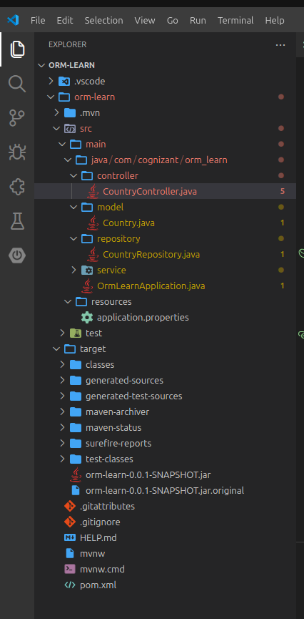

**1.applicationProperties**

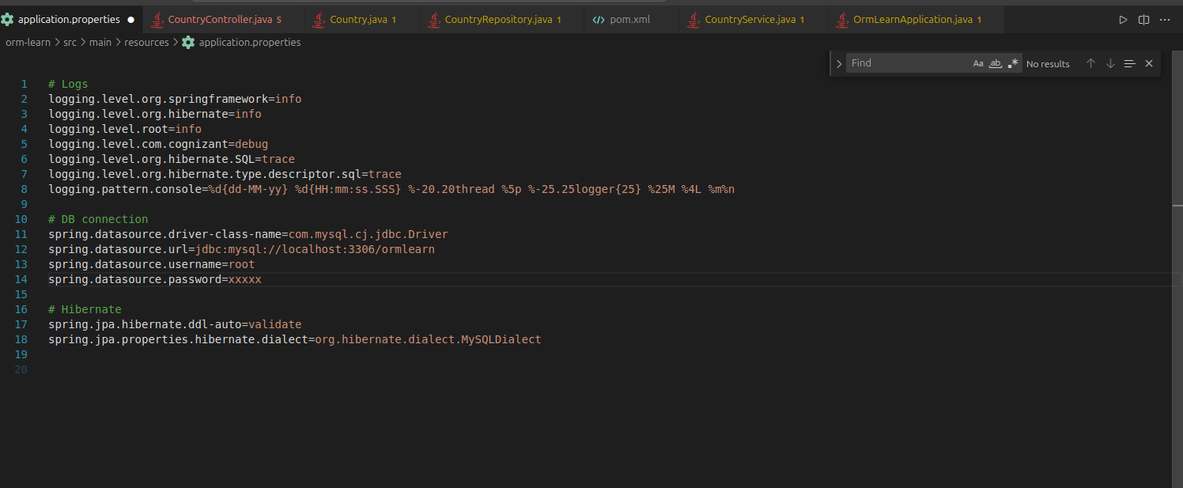

**2.service**

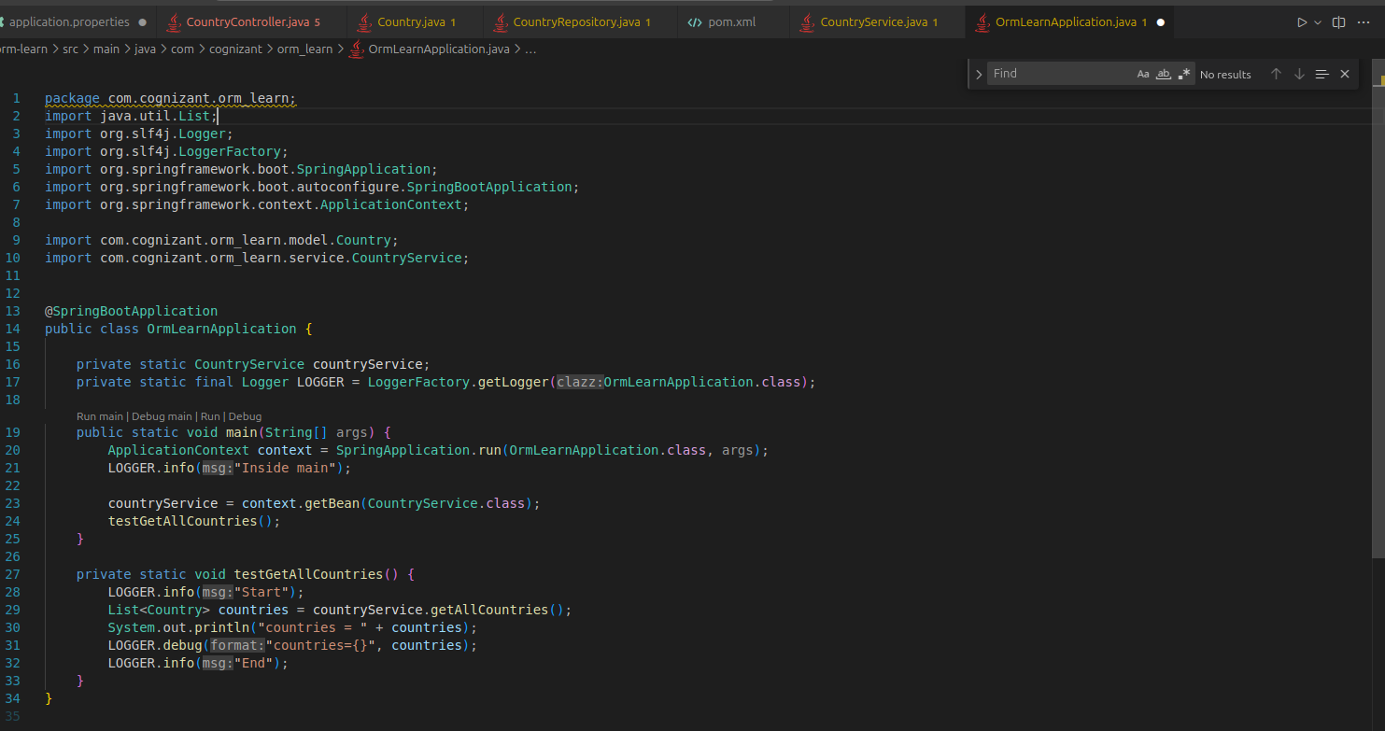

**3.country**

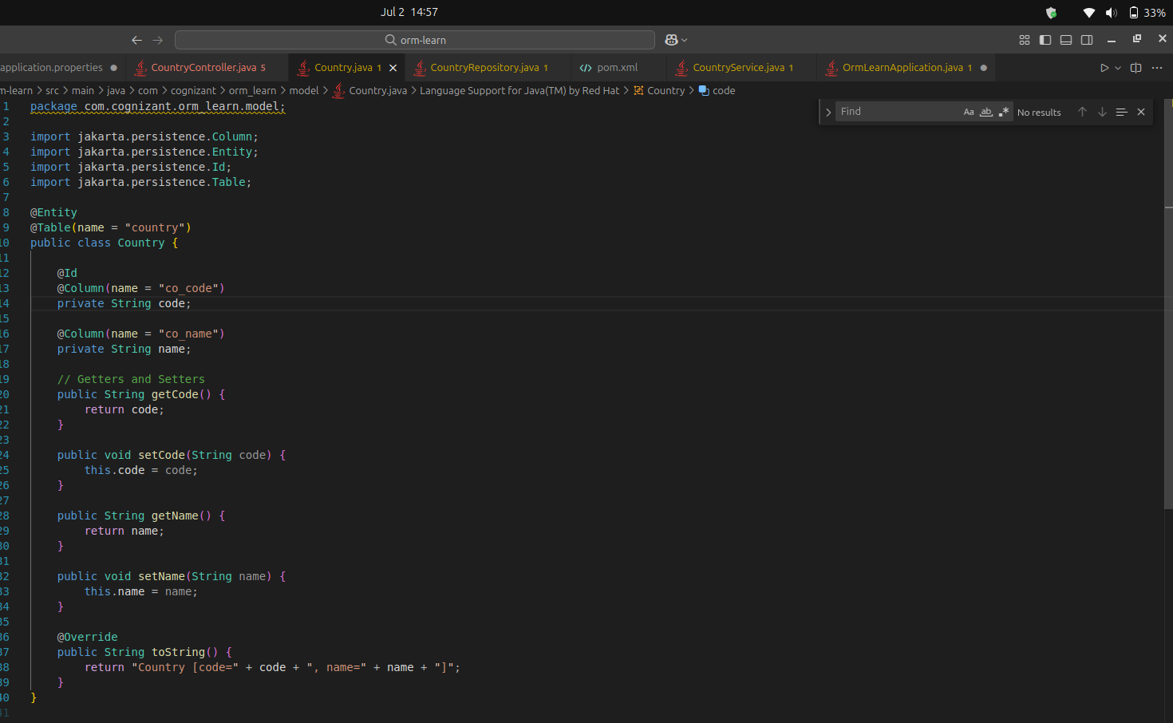

**4.controllers**

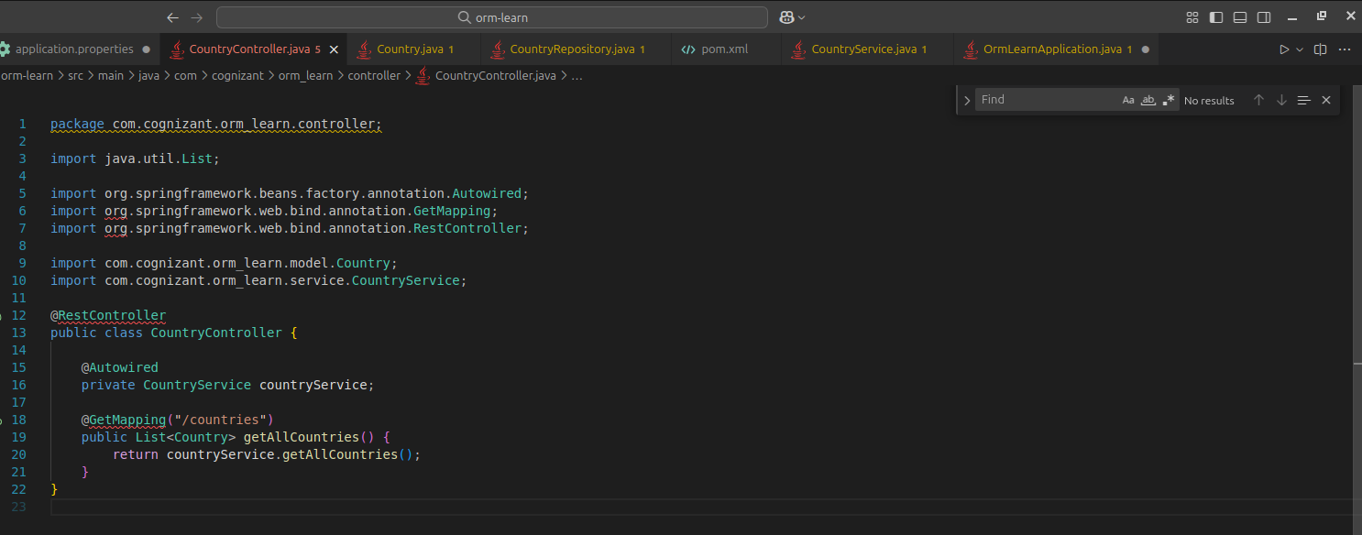

**Execution :**

**mvn clean install || mvn spring-boot:run**

**Outputs :**

**1.**

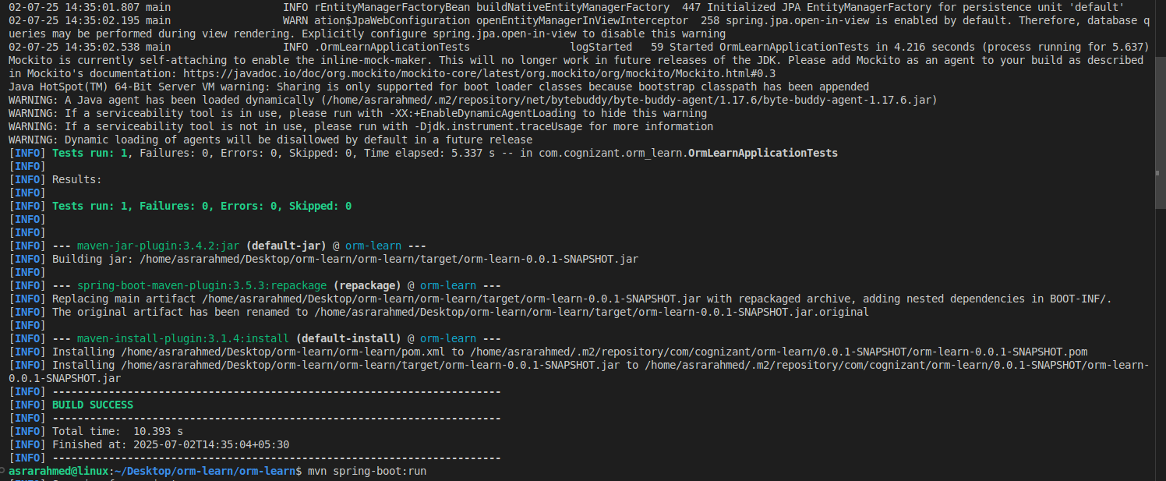

**2.**

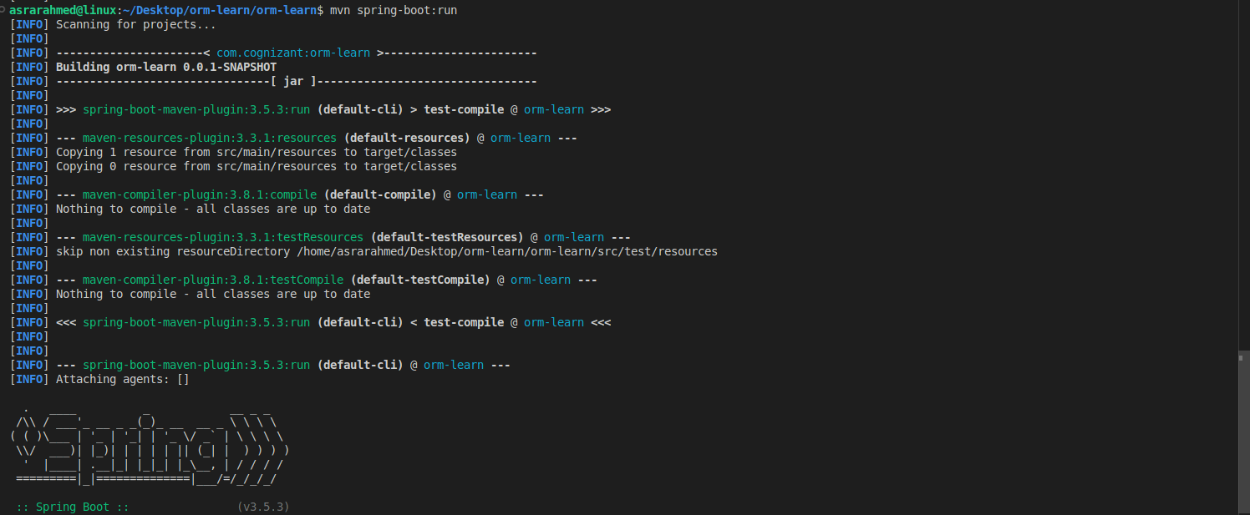

**3.**

